**Shubham Shekhaliya**

**U18CO018**

**Assigment-2 (MIT)**

1 Write Program to shift 8-bit Number by three bits left. Assume data is in register C.

Code:- mvi C, 91H

mov A, C

rlc

rlc

rlc

mov C, A

Output:-

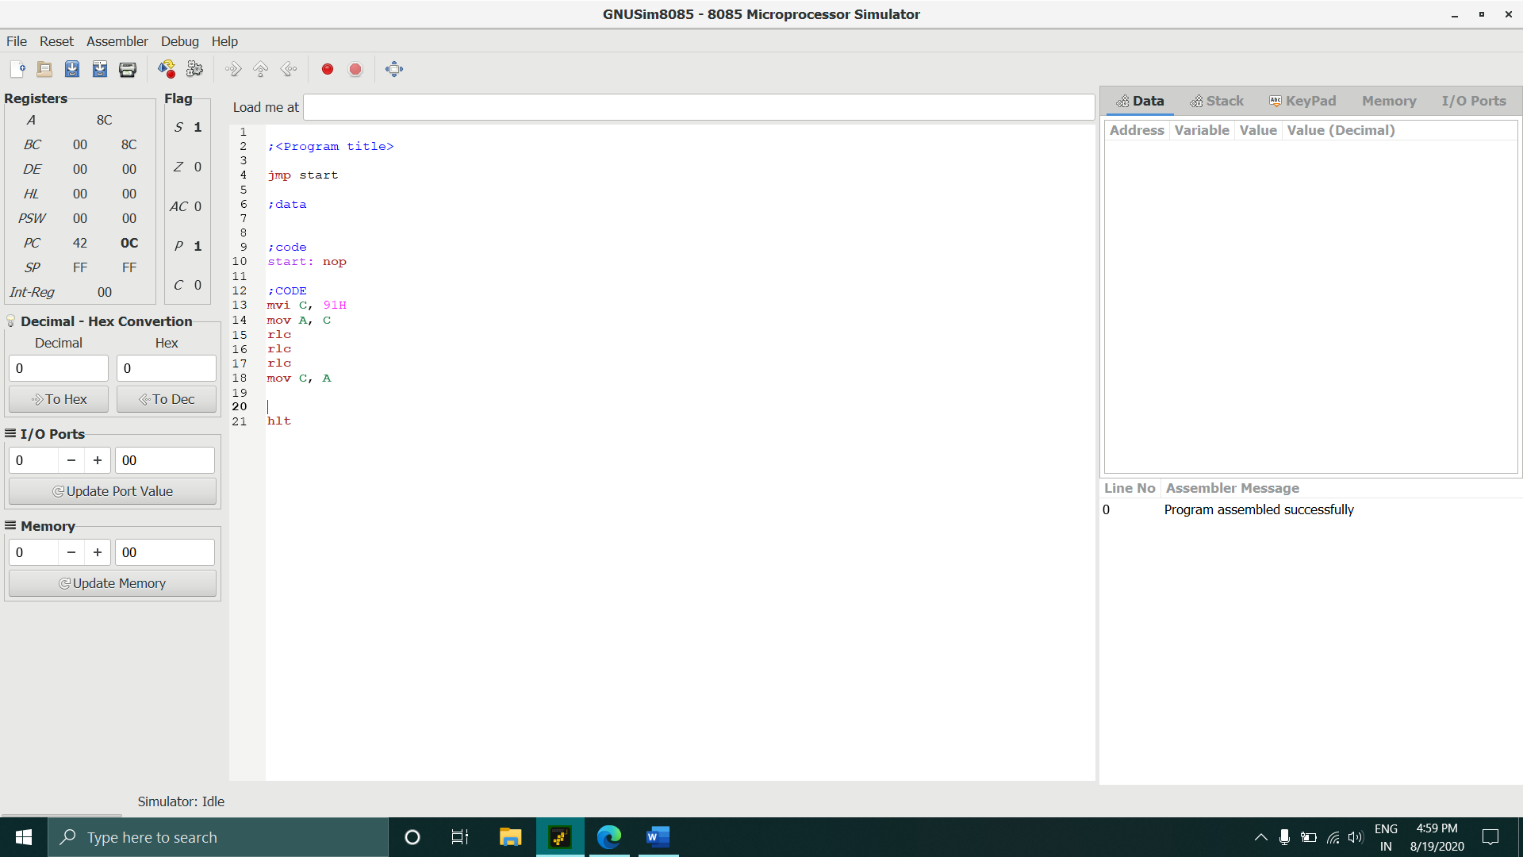

2 Write Program to shift 8-bit data four bits right. Assume data is in Register C.

Code:- mvi C, 91H

mov A, C

rrc

rrc

rrc

rrc

mov C, A

Output:-

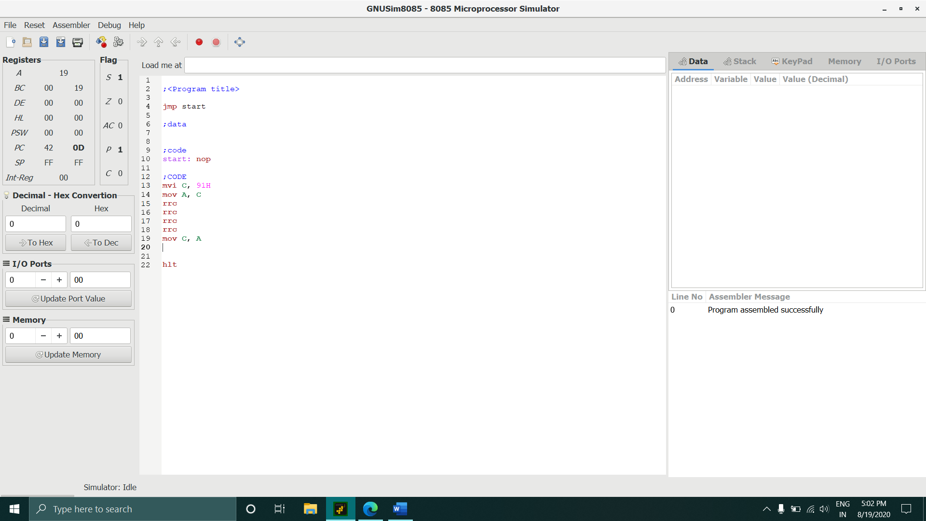

3 Program to Find Sum of Series of 8-bit Numbers.

Code:- LDA 2200H

MOV C,A ;initialize the counter

SUB A ;sum=0

LXI H,2201H ;initalize pointer

BACK: ADD M ;SUM = SUM +data

INX H ;Increment pointer

DCR C ;decrement poniter

JNZ BACK ;if Counter not = 0 repeat

STA 2300H ;store sum

HLT ;terminate program execution

Output:-

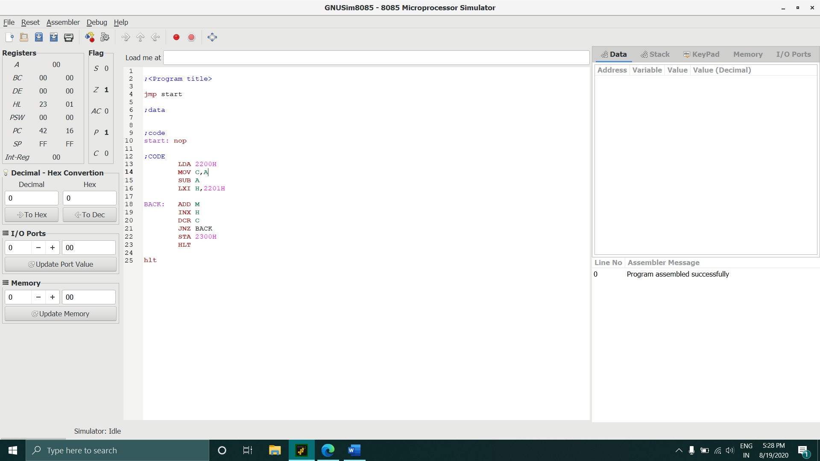

4 Program to Multiply Two 8-bit Numbers.

Code:- mvi C ,5H

mvi E ,7H

mvi A ,00

loop: add C

dcr E

jnz loop

mov C,A

Output:-

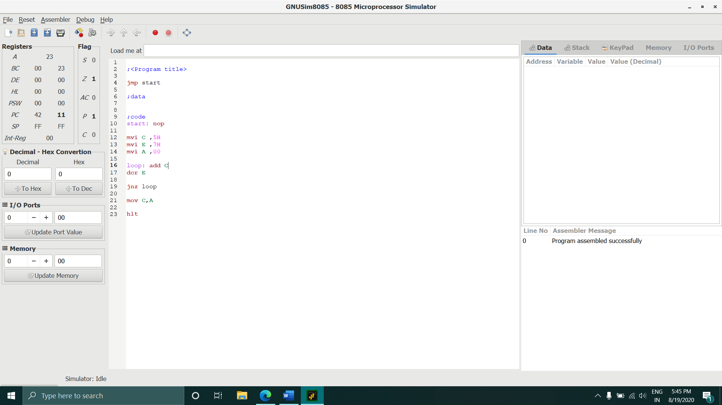

5 Larger of two 8-bit Numbers.

Code:- LXI H,0000H

MOV B,M

INX H

MOV A,M

CMP B

JNC SAVE

MOV A,B

SAVE: STA 0004H

Output:-

